**Unix Command (cont..)**

**Gedit**: To open the notepad terminal

**Chmod** : change file mode bits(permission)

Rwx rwx rwx r-read w-write e-execute

User group others

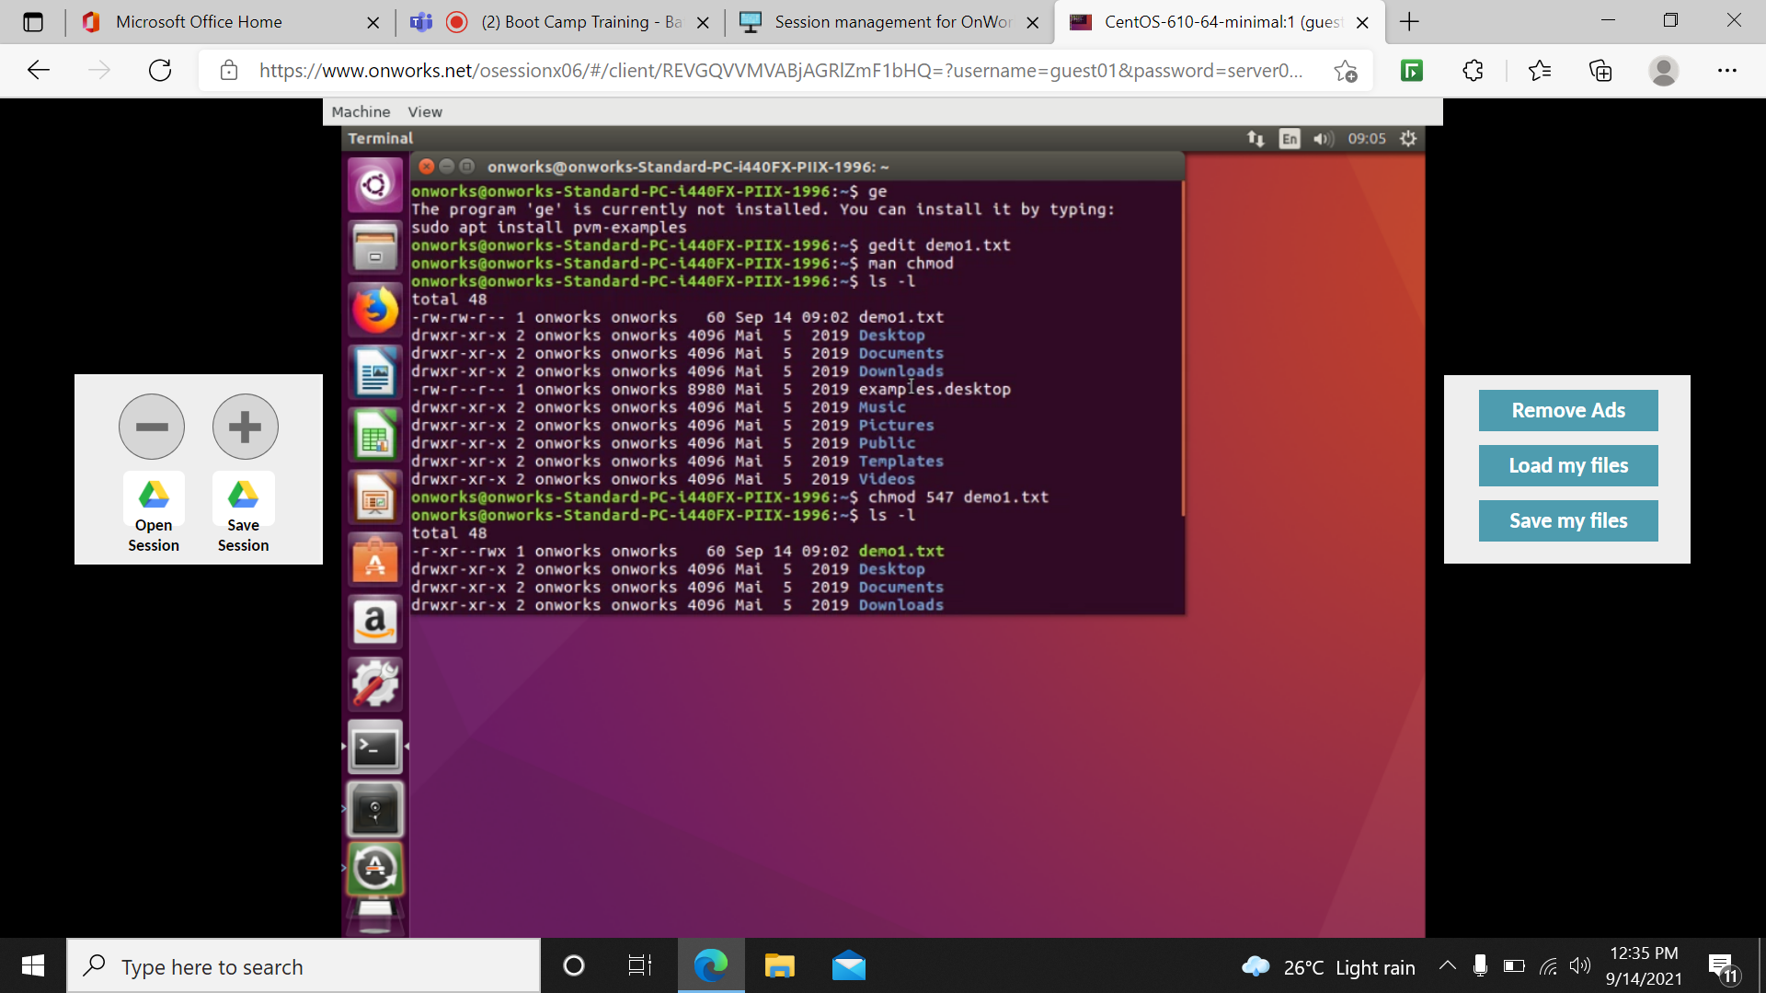

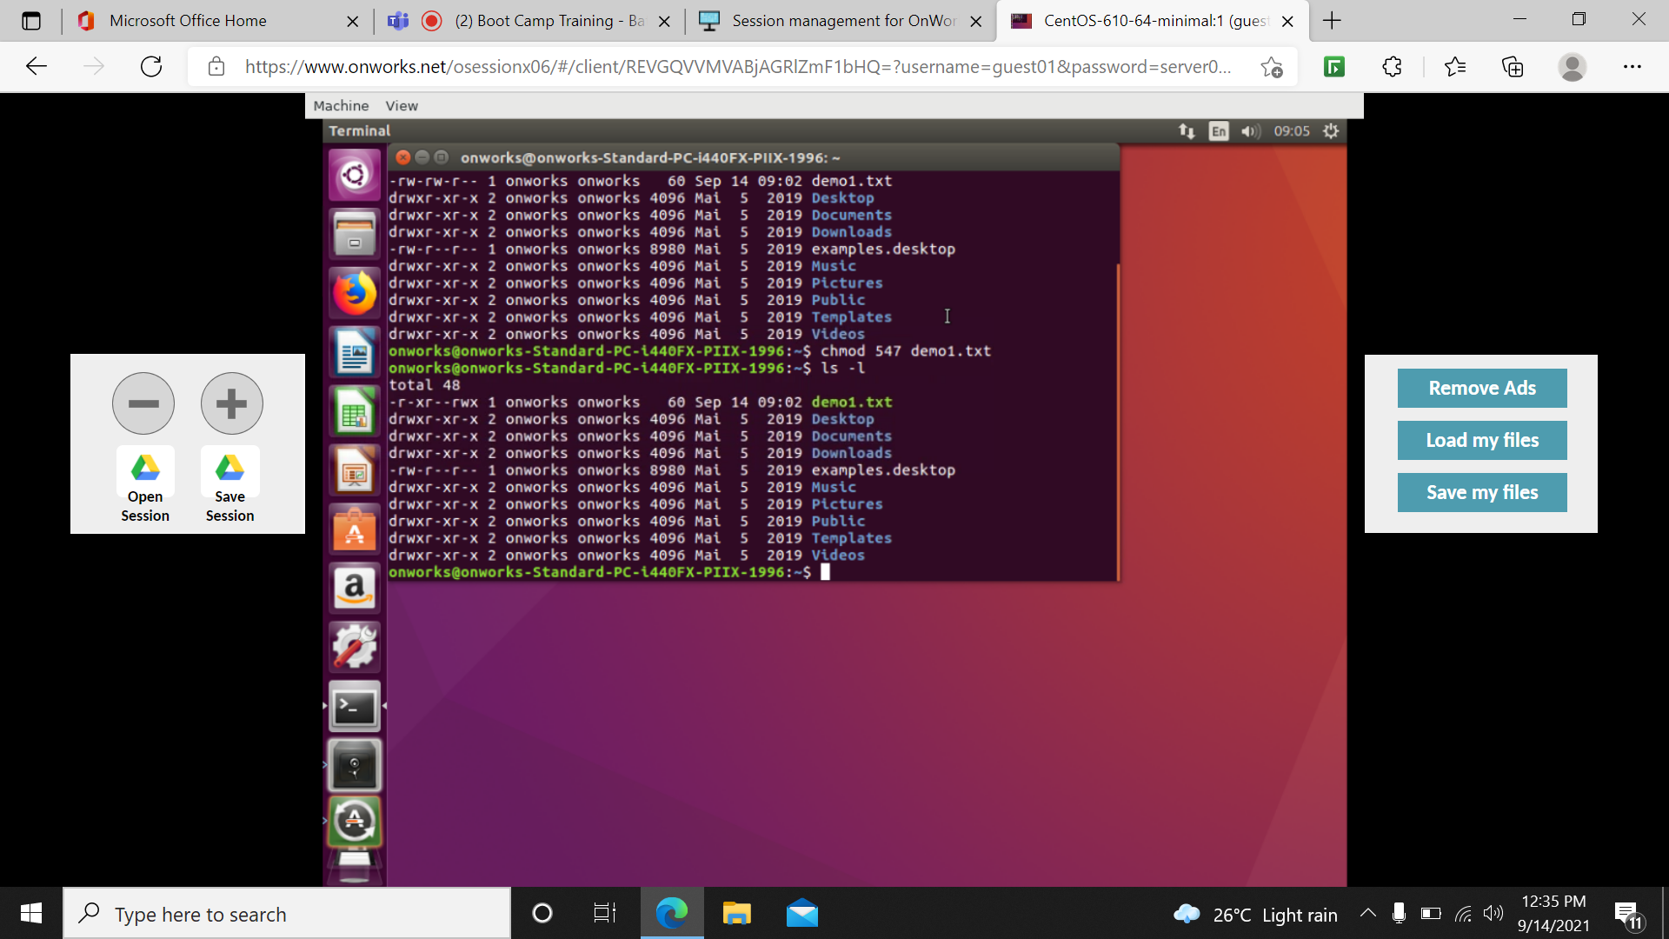

**Vi**-terminal editor which are going to work based on command

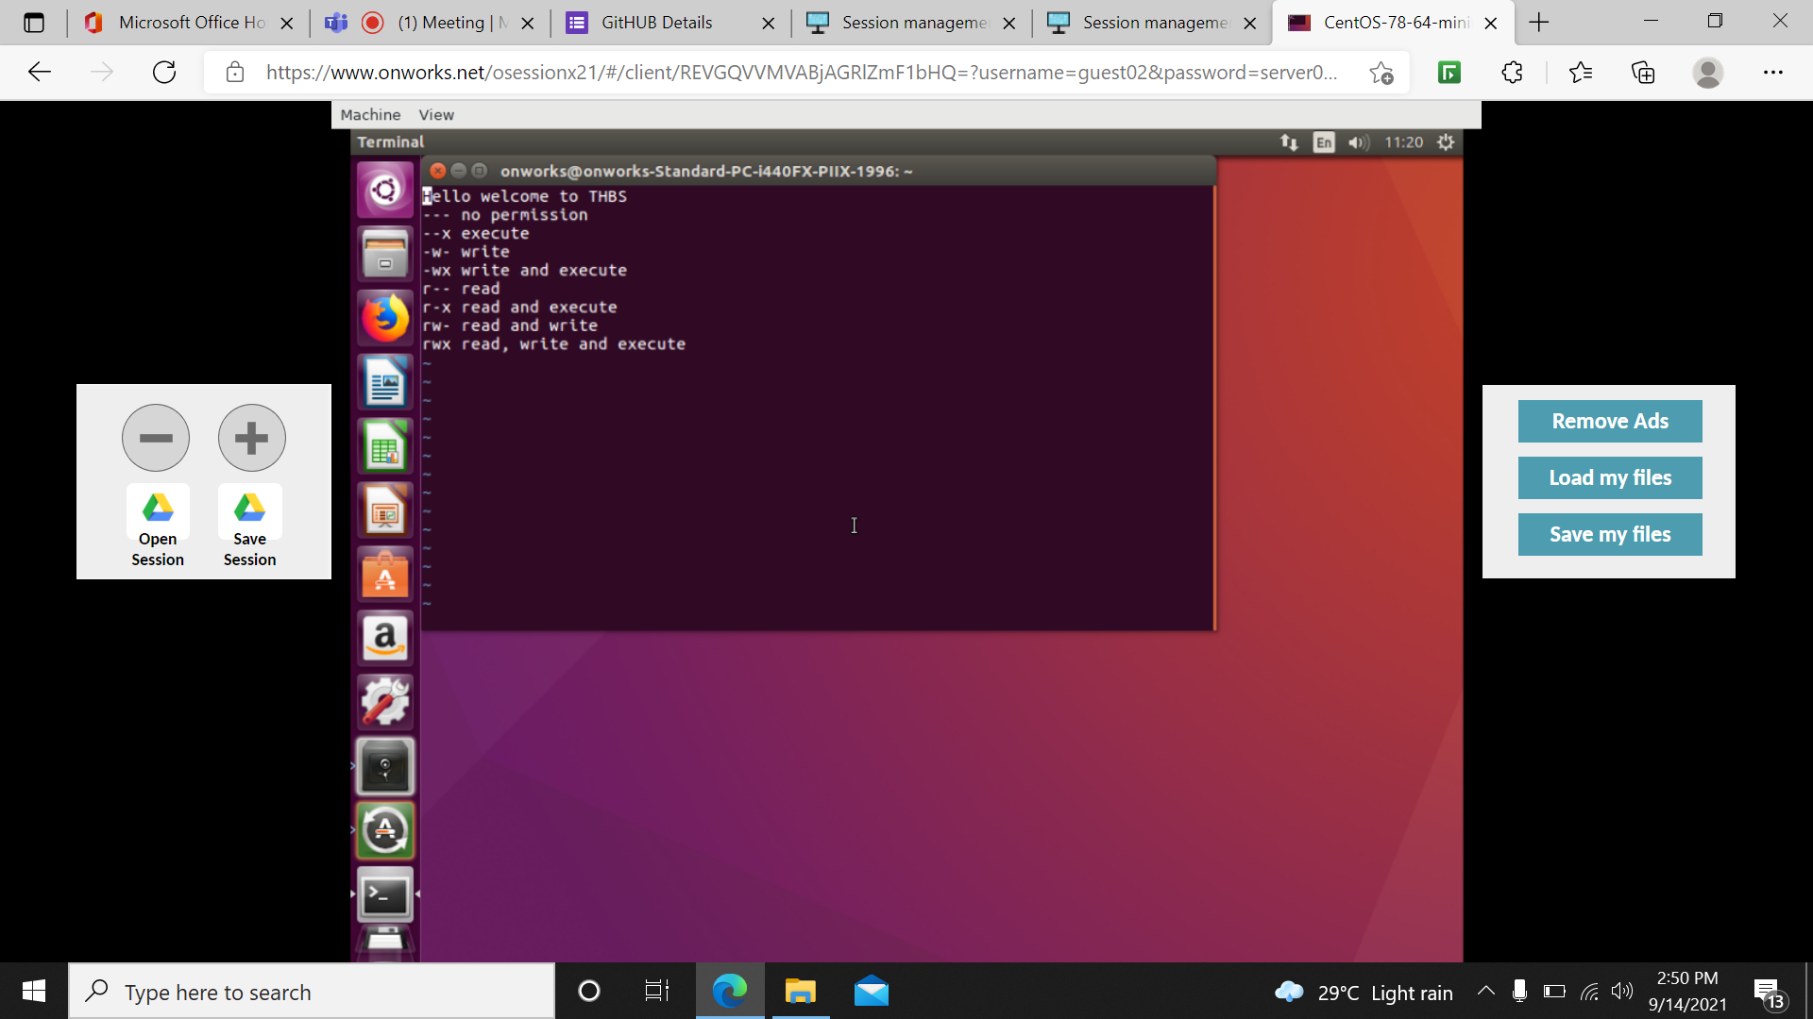

**I-**insert mode/edit

**Ctrl-**r – redo

**d**-to delete

**dw**-delete the complete word 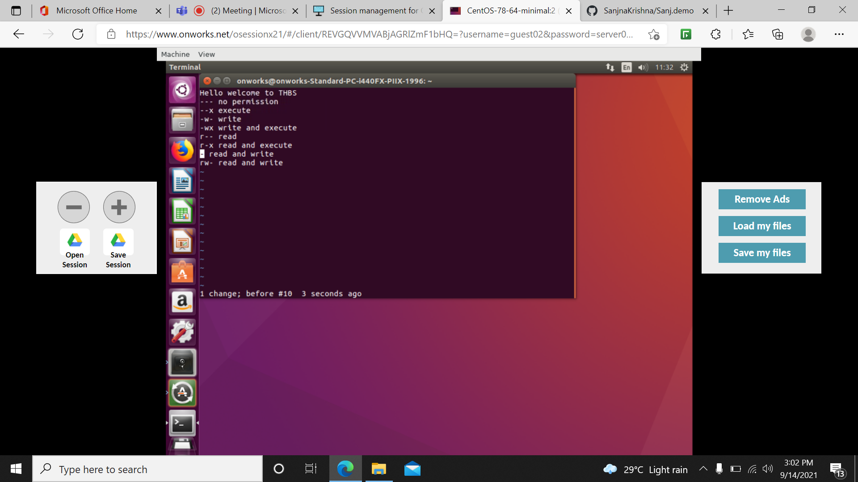

**R-** replace

X-delete single character

U-undo

Yy-copy p-paste

E-end of each word

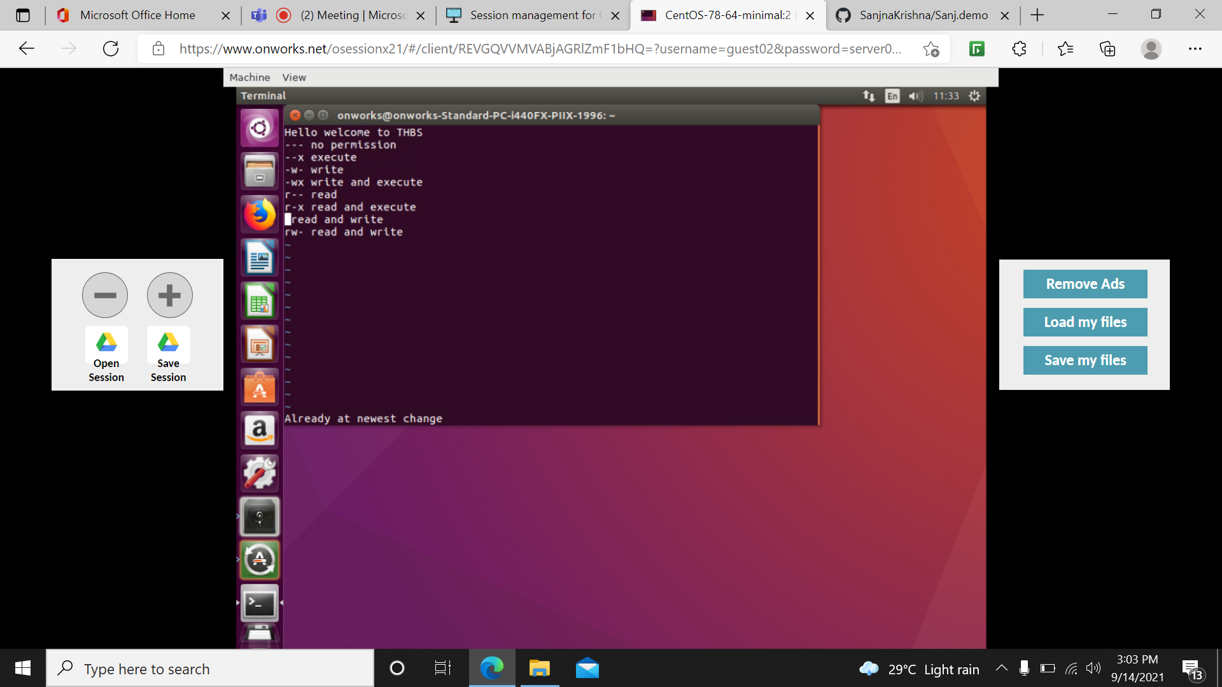

Uname: print system info

Uname –a : shows the version which we are using

Grep: general commands mannal

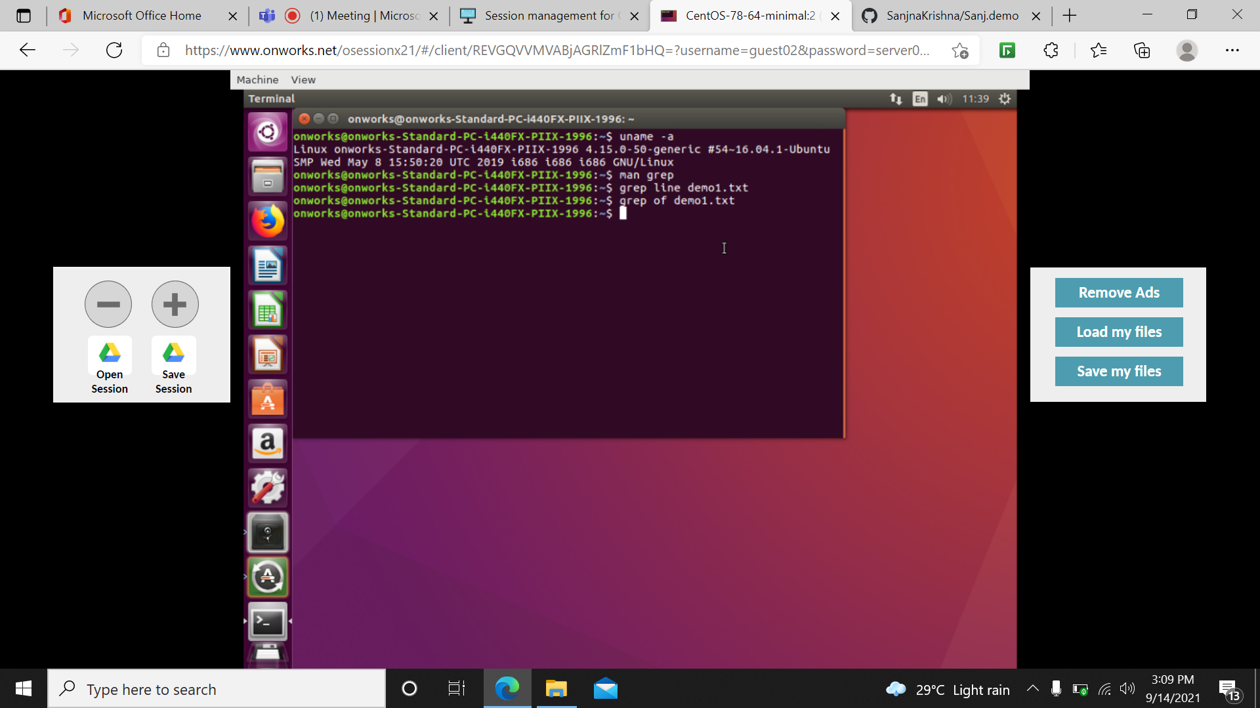

History: gives list of all the commands which we used recently

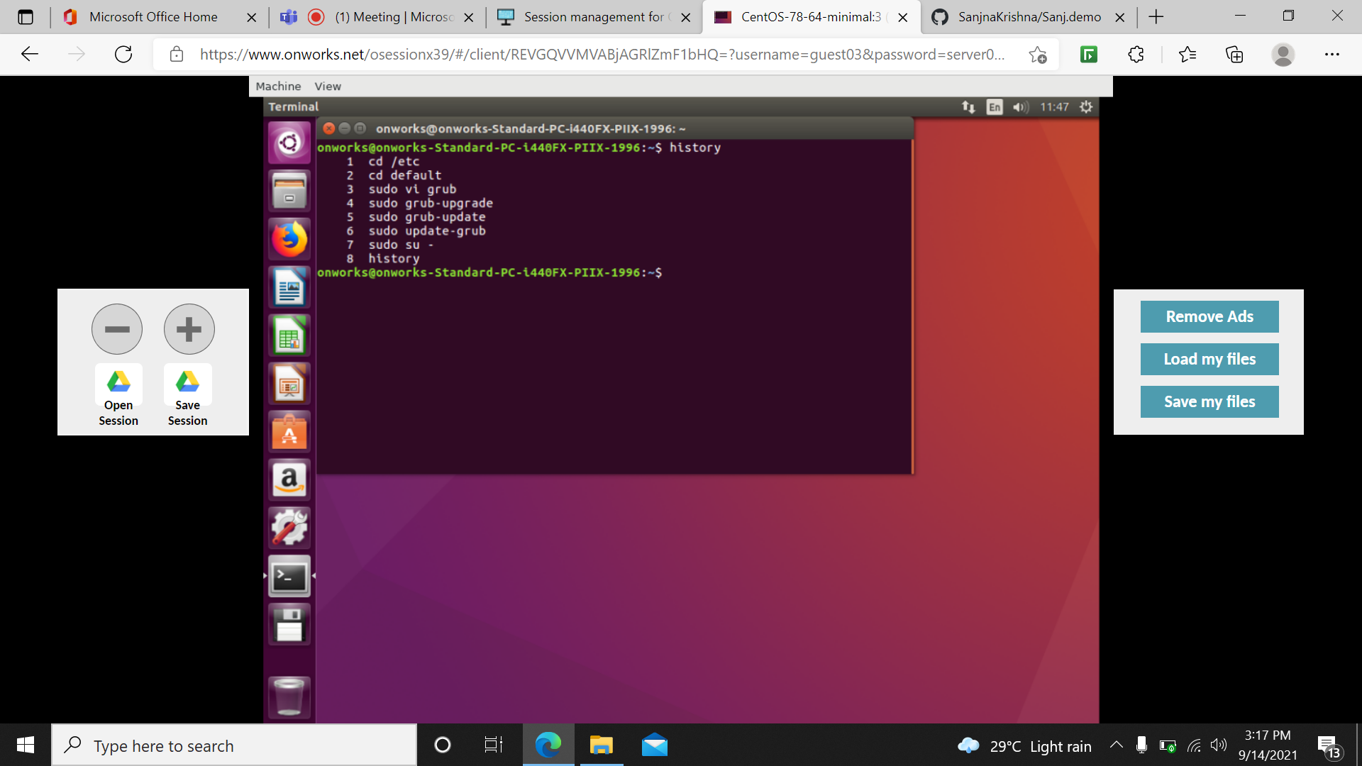

Wget: the non-interactive network downloader. Checks the valid website.

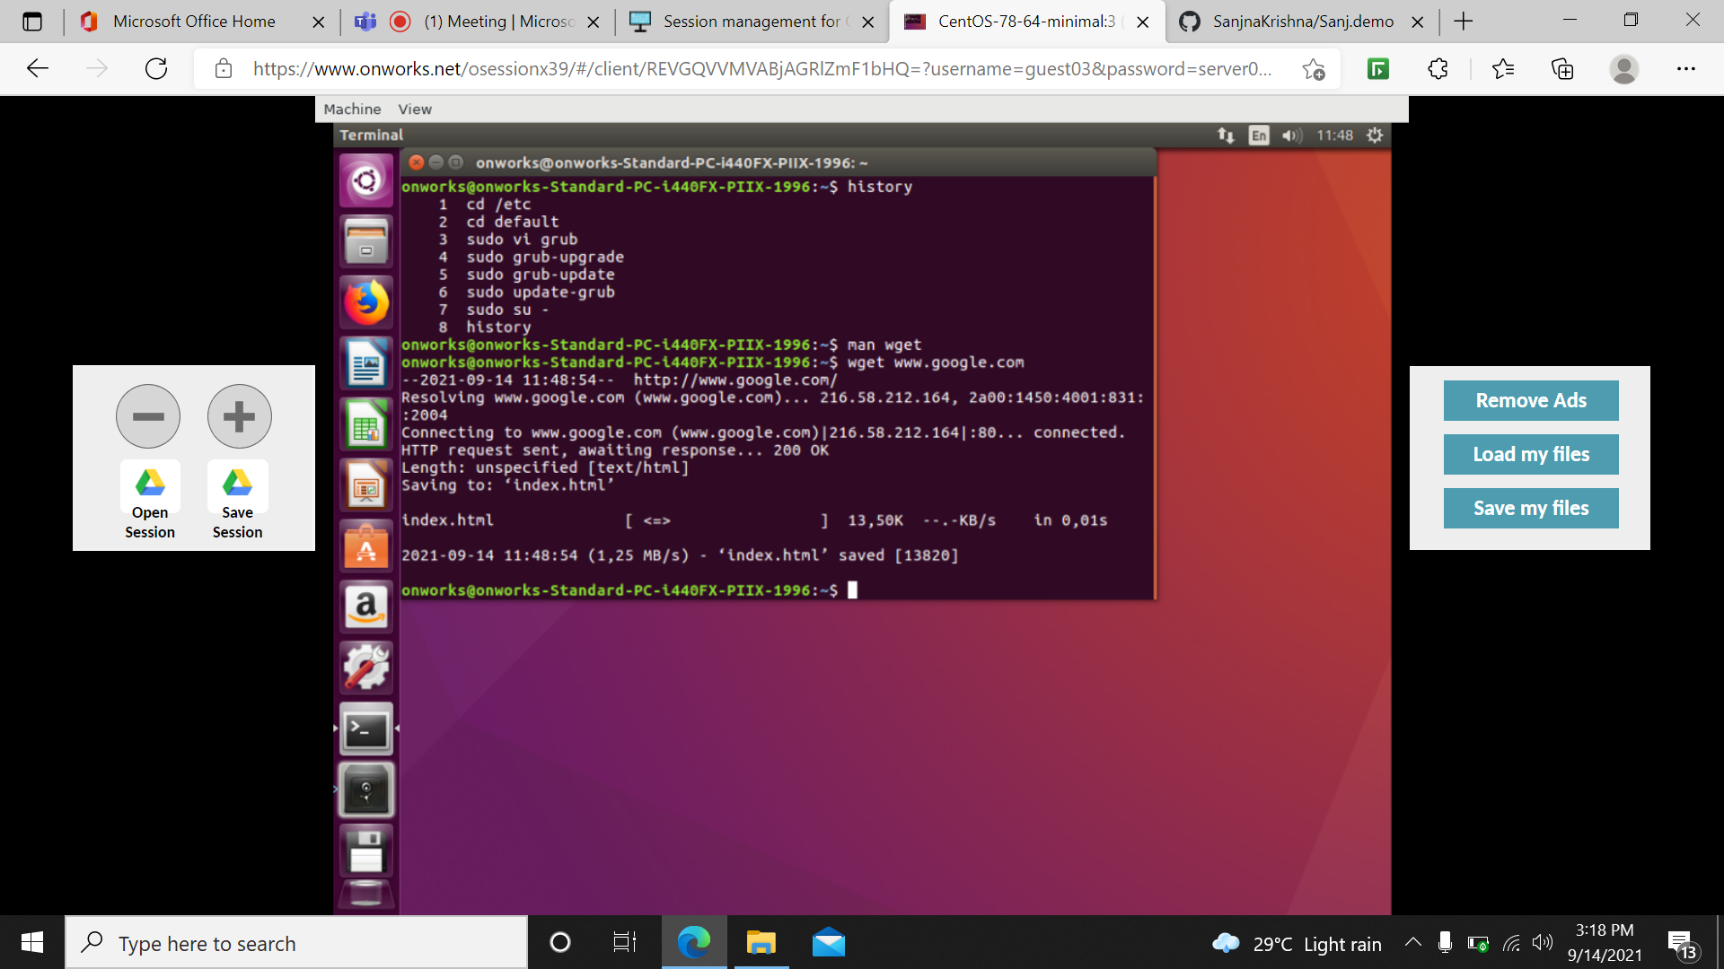

Ip r: gives ip address

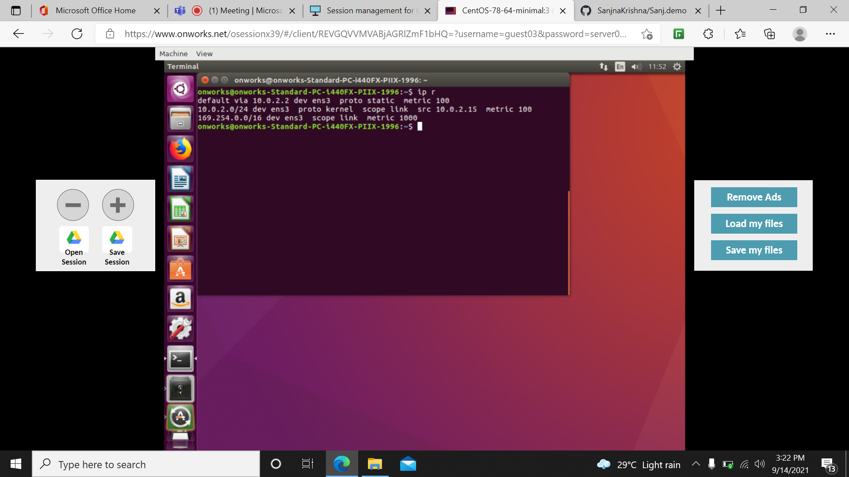

Ifconfig: get you the private ip address of your interface.

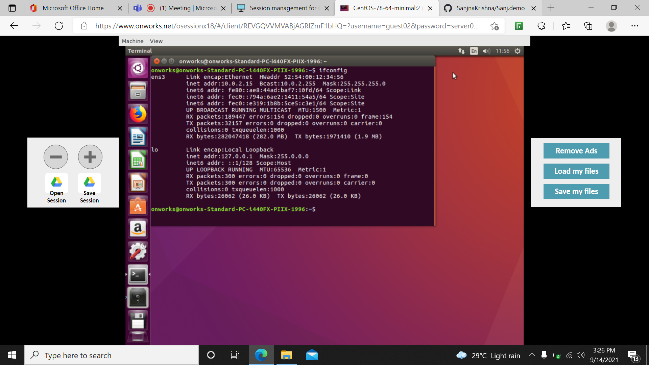

Wc: print newline, word and byte count for each file.

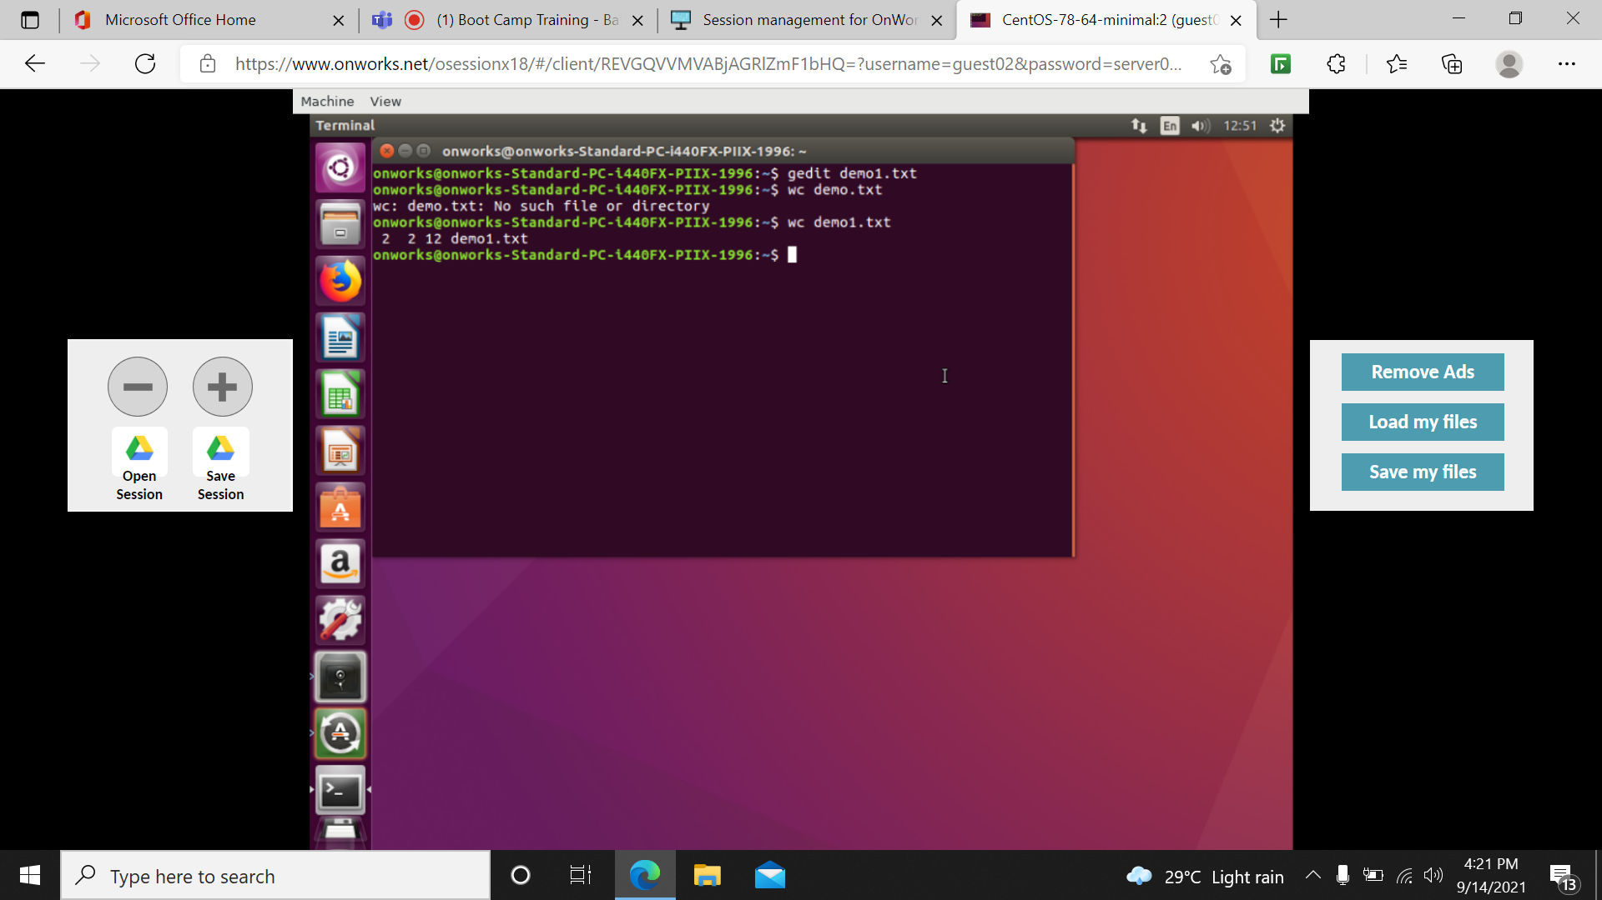

Killall: terminates all the process which are going to run

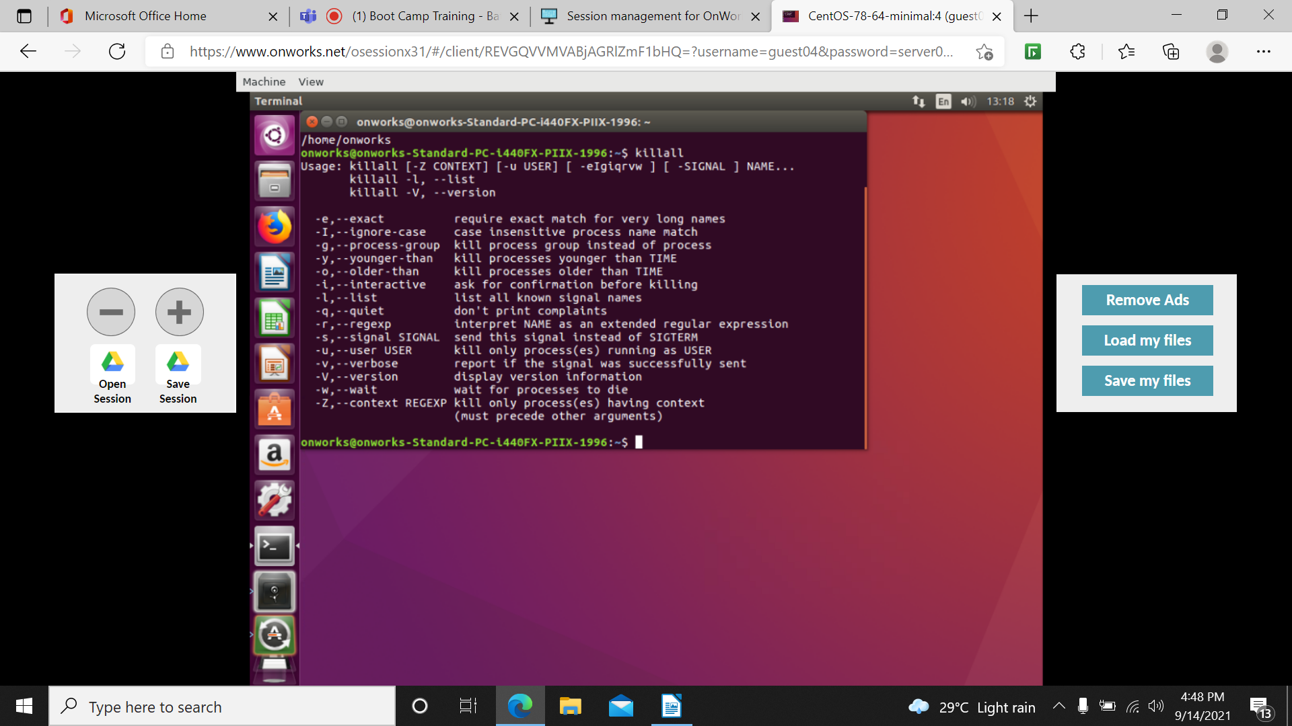

Dirname: names directory

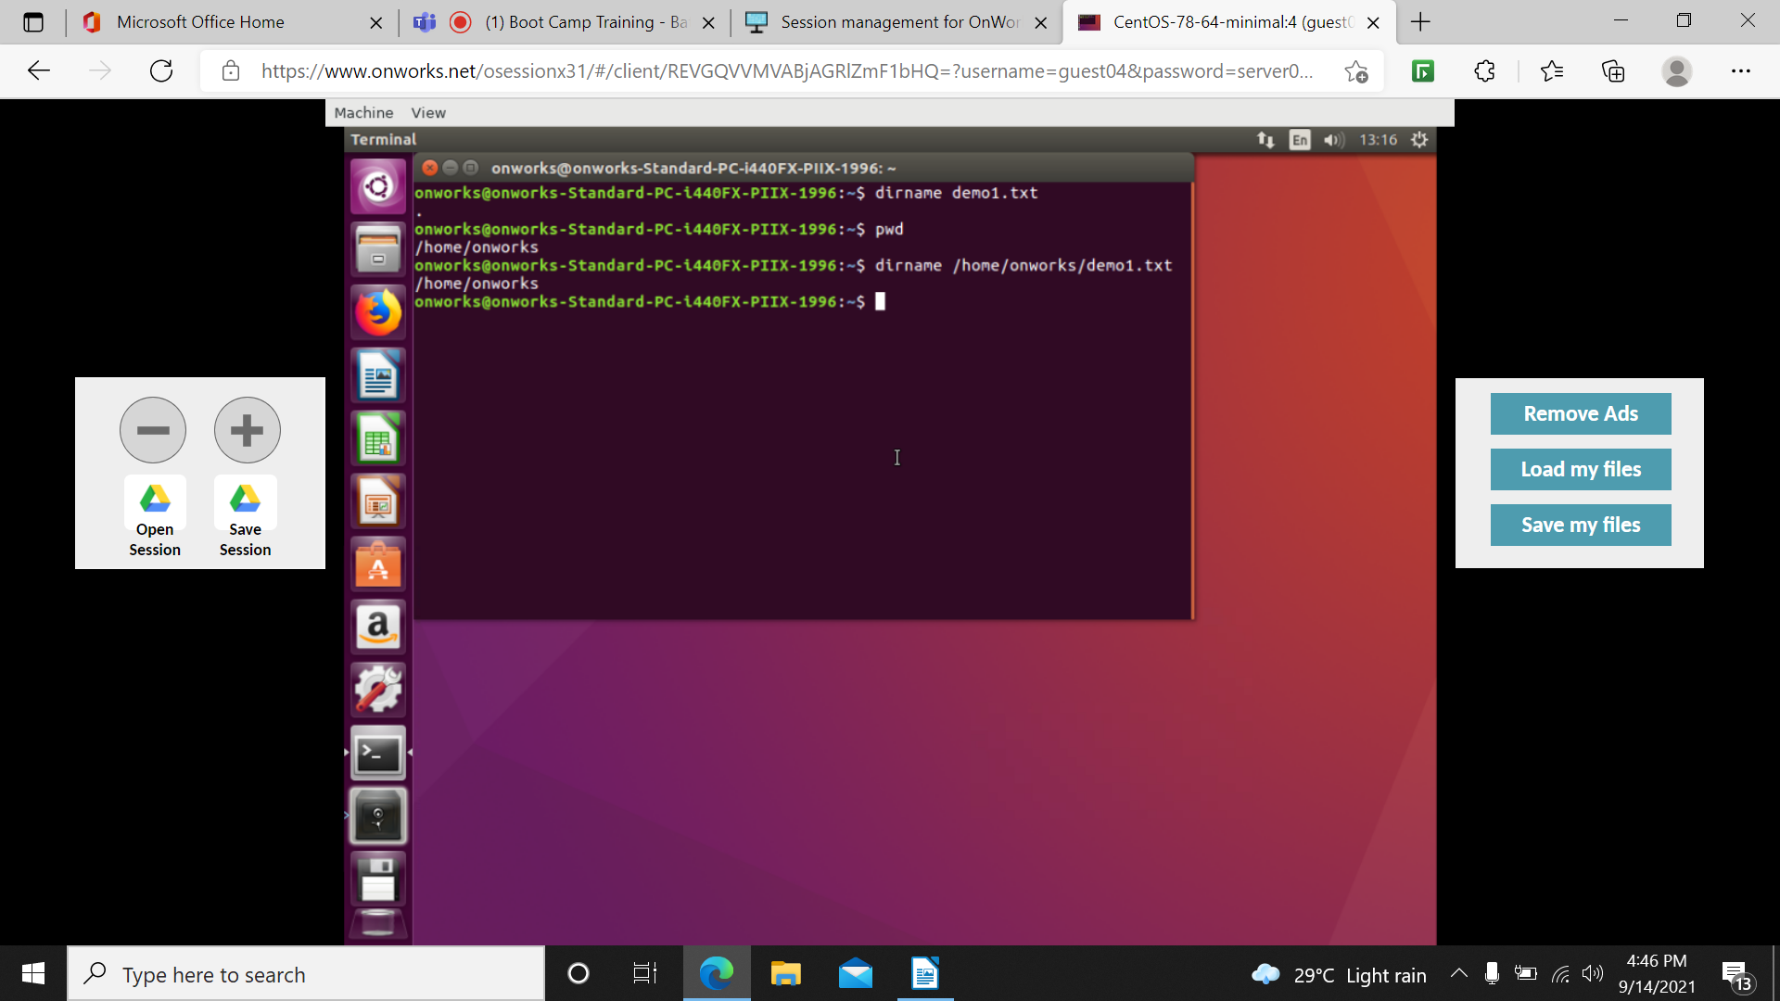

Diff: compares and finds the difference between 2 files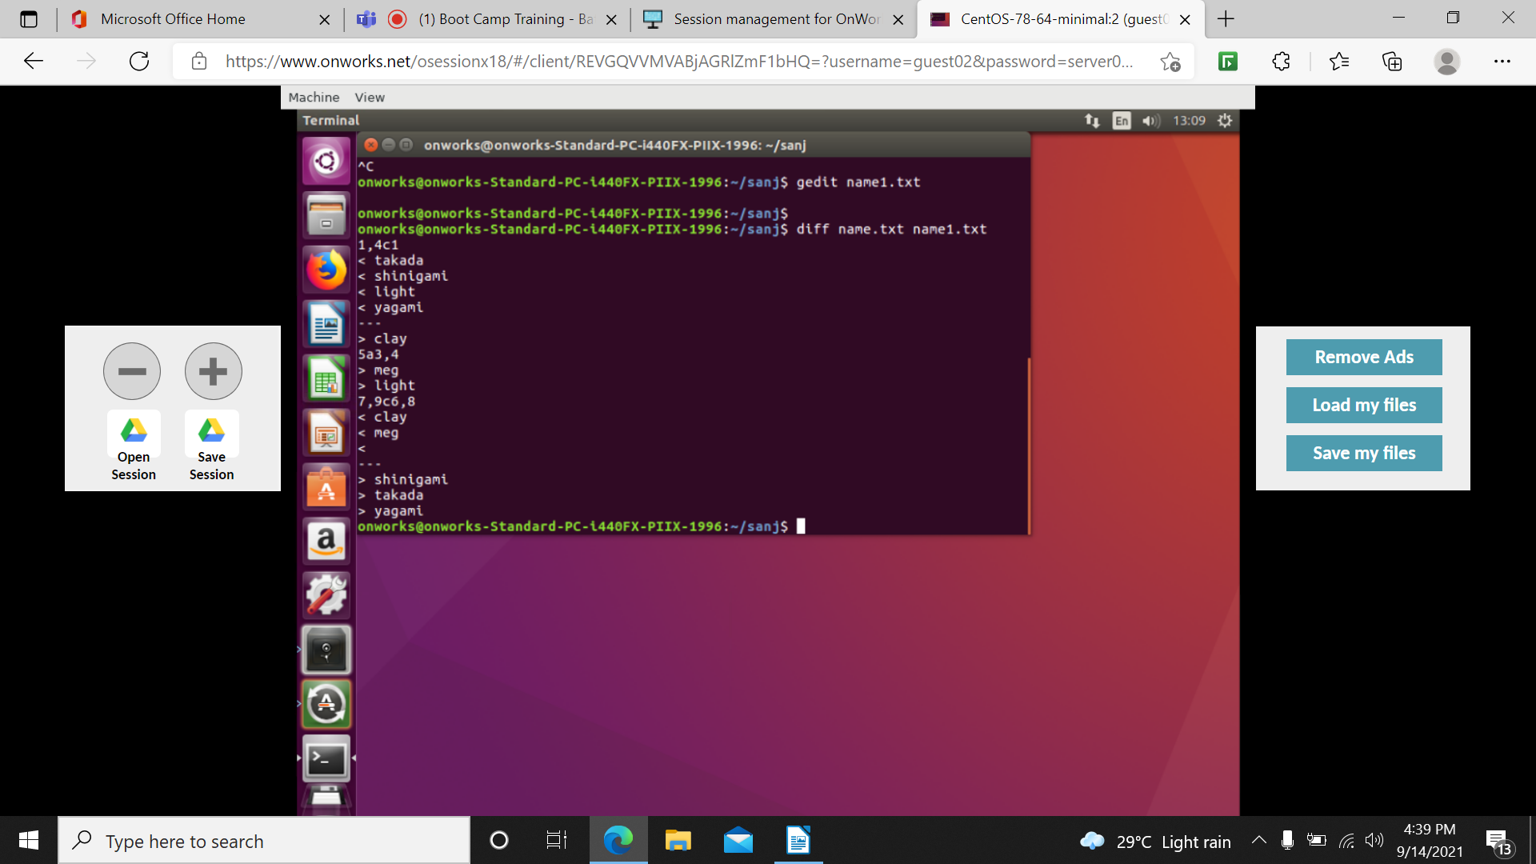

Sort: sorts the content

Sort –r: sorts in reverse

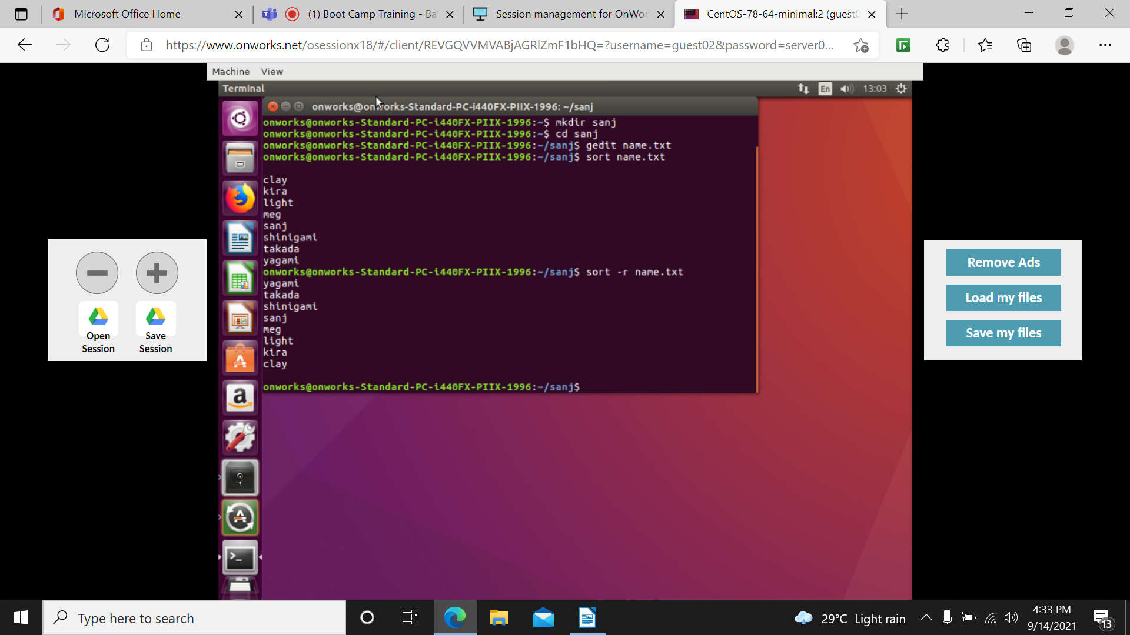

Alias-substitutes the string

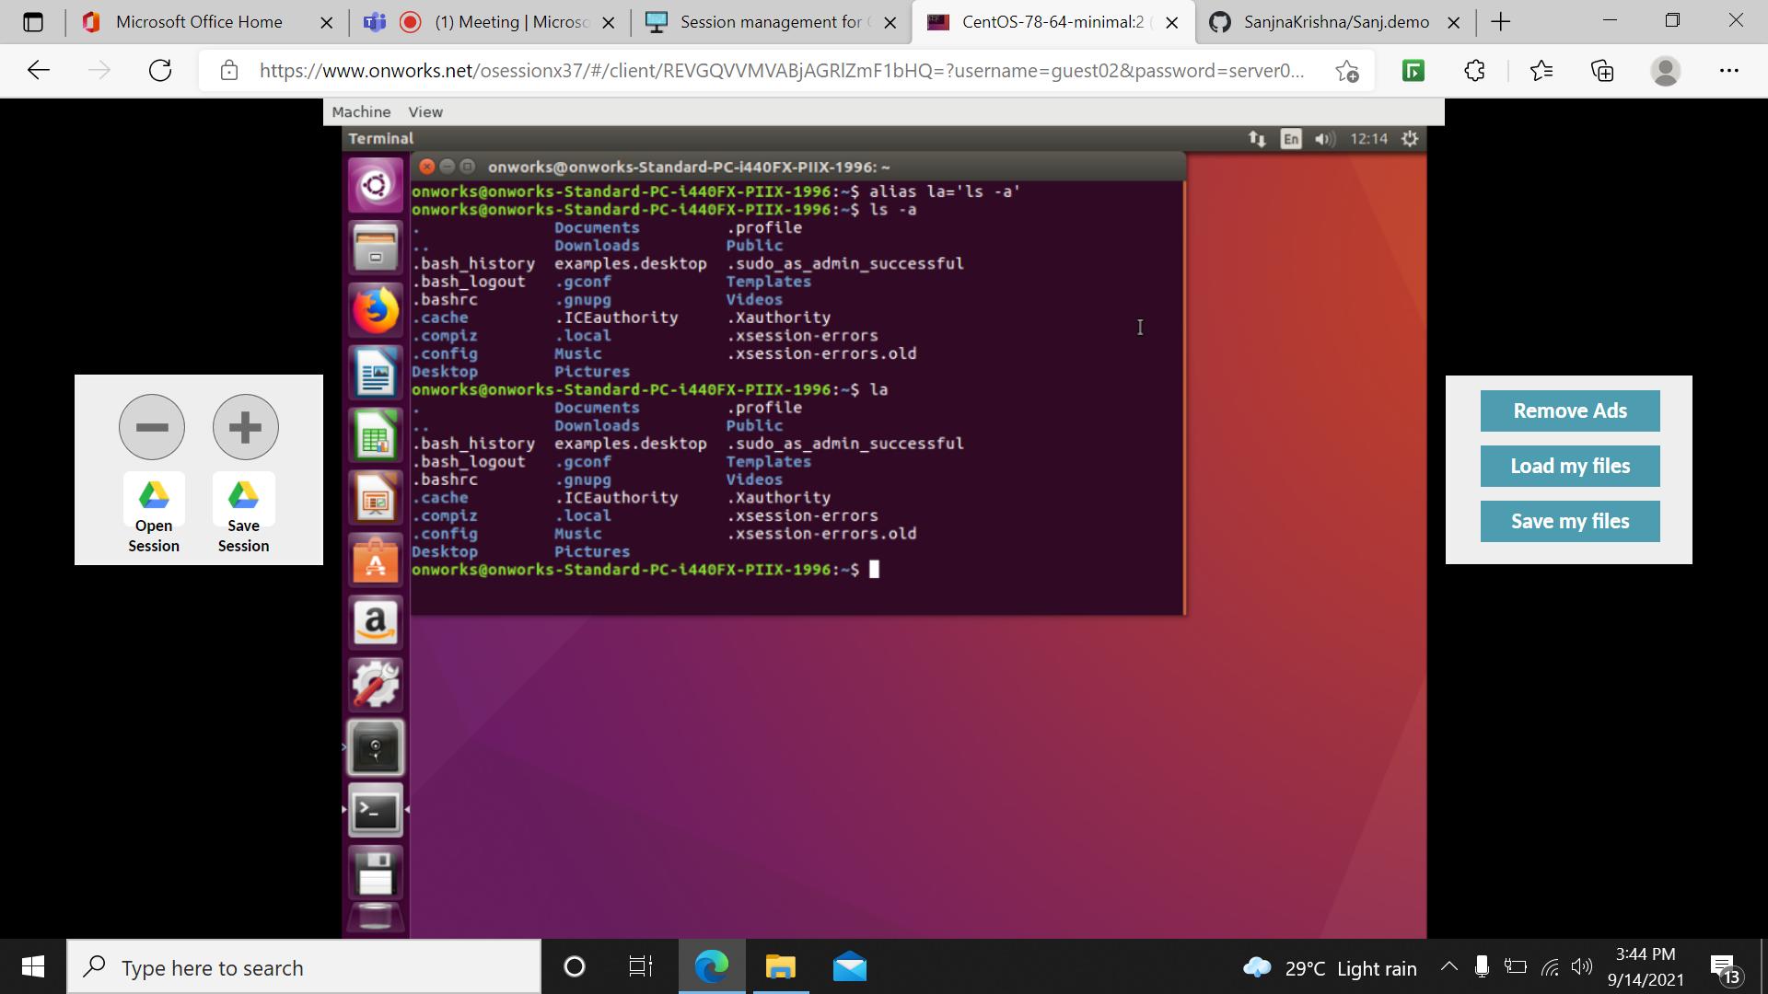

Hostname: shows or set the system’s hostname

Who: show who is logged on

Whoami: print effective userid

Head: displays first 10lines of beginning of files

Tail: displays last 10 lines

Head –n 4: displays first 4 lines

